1.1 Problem Statement
Learning English requires more than memorizing vocabulary and grammar rules. Many learners face difficulties practicing real-world conversations, identifying their mistakes, and applying their knowledge in practical situations. Furthermore, learning materials may not always match learners' proficiency levels, interests, or vocabulary knowledge.
AI-Lingo aims to address these challenges by providing an AI-powered mobile application that generates contextual English conversations based on learners' proficiency levels and selected scenarios. The application also supports vocabulary management, performance evaluation, and learning progress tracking.
The system uses an external AI service to generate learning content and provide feedback. Firebase services support authentication and cloud data storage, while local storage enables learners to access previously saved vocabulary and lessons offline.

1.2 Project Objectives
The main objectives of AI-Lingo are:
- To develop a user-friendly mobile application for practicing English.
2.To generate realistic conversations tailored to learners' proficiency levels and selected scenarios.
3.To provide AI-generated feedback and evaluate learners' conversational performance.
4.To enable learners to save, review, and manage vocabulary.
5.To track completed lessons and provide learning progress indicators.
6.To support offline access to previously saved vocabulary and learning materials.
7.To integrate AI and Firebase services securely and reliably.
8.To develop maintainable and testable software using appropriate architecture and state management techniques.
9.To evaluate the application's functionality, usability, security, and reliability through testing.

2.1system actors and interactions.

Stakeholder | Appears as an Actor? | Reason
Language Learners | Yes | They interact directly with the application.
Academic Supervisor | No | The supervisor's role is to review and evaluate the project, not to use the application as part of its core functionality.
Development Team | No | The team is responsible for development, testing, and maintenance, rather than using the application during normal operation.
AI Service Provider | Yes | It is an external system that interacts with the application to generate content and provide evaluations.
Firebase Service Provider | Yes | It is an external service that supports user authentication and cloud data storage.

2.2Use Case Diagram & Descriptions:
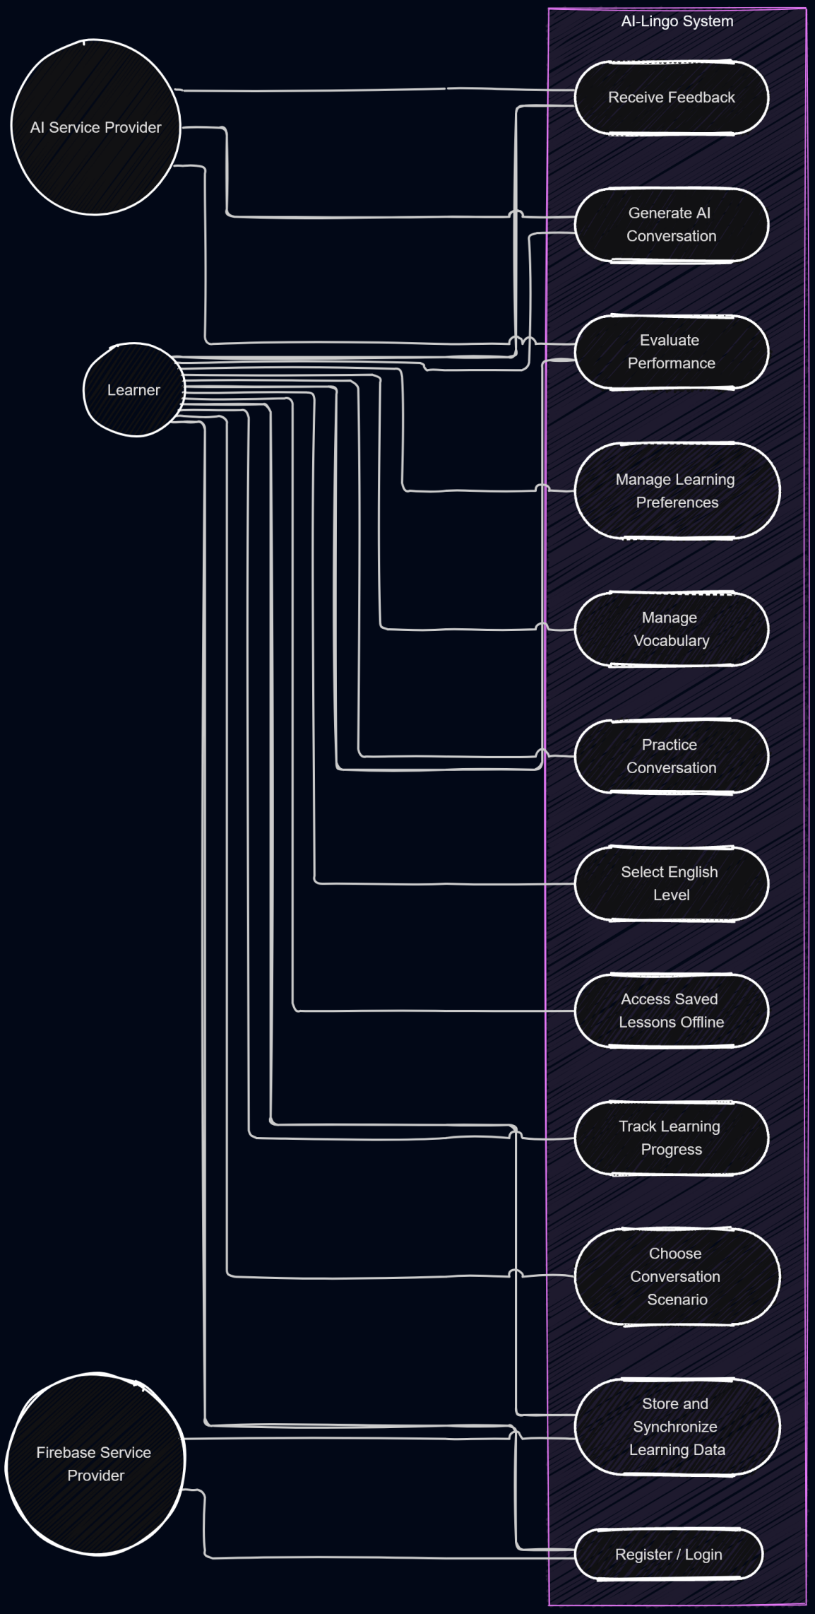

2.3 Use Case Descriptions:
UC-01: Register / Login
Primary Actor: Language Learner
Supporting Actor: Firebase Service Provider
Precondition: The application is available.
Main Flow:
1.The learner opens the application.
2.The learner selects registration or login.
3.The learner enters the required credentials.
4.Firebase Authentication processes the authentication request.
5.The application displays the result and opens the appropriate screen after successful authentication.
Alternative Flow: If authentication fails, the application displays an error message and allows the learner to retry.
Postcondition: The learner is authenticated successfully or remains unauthenticated.

UC-02: Select English Level
Primary Actor: Language Learner
Precondition: The learner has opened the learning section.
Main Flow:
1.The learner selects an English proficiency level or starts an available assessment.
2.The system records the selected or assessed level.
3.The level becomes available for personalizing learning activities.
Alternative Flow: If an assessment is incomplete, the system asks the learner to complete it.
Postcondition: A proficiency level is available for lesson personalization.

UC-03: Choose Conversation Scenario
Primary Actor: Language Learner
Precondition: The learner has opened the conversation section.
Main Flow:
1.The system displays available scenarios.
2.The learner selects a scenario, such as a restaurant conversation, travel situation, or job interview.
3.The system records the selected scenario.
Postcondition: The selected scenario is ready for conversation generation.

UC-04: Generate AI Conversation
Primary Actor: Language Learner
Supporting Actor: AI Service Provider
Preconditions: The learner has selected a scenario and an English proficiency level.
Main Flow:
1.The learner requests a new conversation.
2.The system prepares a prompt containing the selected scenario, proficiency level, and relevant vocabulary information.
3.The system sends the request to the AI service.
4.The AI service generates a contextual conversation.
5.The application displays the generated conversation.
Alternative Flow: If the AI service fails, the application displays an error and offers a retry option.
Postcondition: A generated conversation is available for practice.

UC-05: Evaluate Performance and Receive Feedback
Primary Actor: Language Learner
Supporting Actor: AI Service Provider
Precondition: The learner has submitted a response or completed a supported learning activity.
Main Flow:

1.The learner submits a response for evaluation.
2.The system sends the relevant content to the AI service.
3.The AI service evaluates the response according to the configured criteria.
4.The system displays feedback and relevant improvement suggestions.
Alternative Flow: If the evaluation request fails, the application displays an error and allows the learner to retry.
Postcondition: Feedback is displayed when evaluation succeeds.

UC-06: Manage Vocabulary
Primary Actor: Language Learner
Precondition: The learner can access the vocabulary section.
Main Flow:
1.The learner opens the vocabulary list.
2.The system displays saved words.
3.The learner adds, reviews, or updates vocabulary.
4.The system stores the changes locally.
Postcondition: The vocabulary list reflects the learner's changes.

UC-07: Track Learning Progress
Primary Actor: Language Learner
Precondition: The learner has recorded learning activities or has opened the progress screen for the first time.
Main Flow:
1.The learner opens the progress screen.
2.The system retrieves available learning records.
3.The system calculates relevant progress indicators.
4.The application displays completed lessons and learned vocabulary.
Alternative Flow: If no learning activity is recorded, the system displays an appropriate empty state.
Postcondition: The learner can view the available progress information.

UC-08: Access Saved Lessons Offline
Primary Actor: Language Learner
Precondition: The learner has previously saved lessons or vocabulary locally.
Main Flow:
1.The learner opens the saved learning materials section.
2.The system retrieves locally stored content.
3.The application displays the available materials.
4.The learner selects and reviews a saved lesson.
Alternative Flow: If no local content exists, the application informs the learner that saved materials are required for offline access.
Postcondition: Previously saved content is accessible without an internet connection.

UC-09: Store and Synchronize Learning Data
Primary Actor: Language Learner
Supporting Actor: Firebase Service Provider
Precondition: The learner is authenticated when cloud synchronization is required.
Main Flow:
1.The learner performs an activity that produces data to be saved.
2.The system stores supported learning data locally or in the cloud, according to the data type.
3.When cloud synchronization is enabled and connectivity is available, the system updates the relevant cloud records.
4.The system reports the result where appropriate.

Alternative Flow: If cloud synchronization fails, the application handles the error and preserves locally stored data where supported.
Postcondition: The data is stored locally or in the cloud according to the applicable storage and synchronization rules.
*********************************************************************

3. Functional & Non-Functional Requirements
3.1 Functional Requirements:

Functional Requirements
FR-01: Authentication
The system shall allow learners to register, log in, and log out using Firebase Authentication.
FR-02: Learning Preferences
The system shall allow learners to configure relevant learning preferences.
FR-03: English Level Selection
The system shall allow learners to select their proficiency level or complete an implemented assessment.
FR-04: Scenario Selection
The system shall provide conversation scenarios relevant to practical English usage.
FR-05: AI Conversation Generation
The system shall generate contextual conversations through the configured AI service using the selected scenario and proficiency level.
FR-06: Conversation Practice
The system shall allow learners to practice generated conversations by submitting supported responses.
FR-07: Performance Evaluation
The system shall provide AI-generated feedback according to the implemented evaluation criteria.
FR-08: Vocabulary Management
The system shall allow learners to save, review, and manage vocabulary.
FR-09: Learning Progress
The system shall track supported learning activities and display relevant progress indicators.
FR-10: Offline Learning
The system shall allow learners to access previously saved vocabulary and supported learning materials without an internet connection.
FR-11: Cloud Data Storage
The system shall store supported user-specific information in Cloud Firestore.
FR-12: Error Handling
The system shall handle authentication failures, network problems, and AI service errors without unexpected termination.
3.2 Non-Functional Requirements
NFR-01: Performance
The application should load locally stored vocabulary and saved lessons without unnecessary delays.
NFR-02: Security
The system must protect user data through appropriate authentication, authorization, and secure data handling practices.
NFR-03: Privacy
The system should send only the information necessary for generating or evaluating learning content.
NFR-04: Reliability
The application must handle network failures, authentication errors, and invalid AI responses without unexpected termination.
NFR-05: Usability
The interface should be intuitive and consistent, allowing learners to navigate between conversations, vocabulary, and progress screens easily.
NFR-06: Offline Availability
Previously saved vocabulary and supported cached learning materials must remain accessible without an internet connection.
NFR-07: Maintainability
The codebase should separate presentation, business logic, and data access responsibilities.
NFR-08: Testability
Core business logic and important user interface states should be testable through unit tests and widget tests.
NFR-09: Compatibility
The application must be tested on the Android versions and device configurations selected as project targets.
NFR-10: Scalability
The architecture should support adding new conversation scenarios and learning activities without major changes to existing components.
NFR-11: Documentation
The project shall maintain clear technical documentation describing its requirements, architecture, implementation, and testing.
*********************************************************************

3.3 System Capabilities
The AI-Lingo application provides the following capabilities to support personalized English language learning:
1.User Authentication: The system allows learners to register and log in using Firebase Authentication.
2.Personalized Learning: The system allows learners to select their English proficiency level and preferred learning scenarios.
3.AI-Powered Conversation Generation: The system generates contextual English conversations using an external AI service based on the learner's selected level and scenario.
4.Interactive Conversation Practice: The system allows learners to practice English through AI-generated dialogues and submit responses.
5.Performance Evaluation: The system provides AI-generated feedback on learners' responses, including grammar and vocabulary suggestions.
6.Vocabulary Management: The system enables learners to save, review, and manage vocabulary using local storage.
7.Learning Progress Tracking: The system records learning activities and displays progress indicators, such as completed lessons and learned vocabulary.
8.Offline Learning: The system allows learners to access previously saved vocabulary and supported learning materials without an internet connection.
9.Cloud Data Storage: The system uses Firebase services to store supported user data and retrieve it when required.
***************************************************************

3.4 System Constraints
The development and operation of AI-Lingo are subject to the following constraints:
1.Internet Connectivity: Generating new AI conversations and accessing cloud services require an internet connection. Offline functionality is limited to previously saved local content.
2.AI Service Dependency: Conversation generation and AI-based evaluation depend on the availability, response quality, usage limits, and applicable policies of the external AI service.
3.API Usage and Cost Limits: AI requests are subject to the selected service's quotas, rate limits, and pricing conditions.
4.Platform Compatibility: The initial application release targets Android devices within the selected supported OS versions and device configurations.
5.Local Storage Limitations: Offline access is restricted to vocabulary and learning materials previously stored on the device.
6.Data Synchronization: Cloud synchronization depends on network availability and the correct configuration of Firebase Authentication and Cloud Firestore.
7.Security Requirements: User-specific cloud data must be protected through appropriate authentication and database security rules. Sensitive credentials must not be embedded directly in the distributed application.
8.Project Scope: The initial release focuses on text-based English conversation practice, vocabulary management, feedback, and progress tracking. Advanced voice conversations and advanced gamification are outside the initial scope unless explicitly added to the project requirements.
9.Development Resources: Implementation and testing are constrained by the available development time, team size, service quotas, and testing devices.
***************************************************************

4. Software Architecture:
AI-Lingo will follow the Model–View–ViewModel (MVVM) architectural pattern to separate the user interface, application logic, and data operations. This separation will improve code organization, maintainability, testability, and the ability to extend the application in the future.
The architecture consists of three main components:

1. View
The View represents the user interface of the application. It includes the screens through which learners interact with AI-Lingo, such as the login and registration screens, learning preferences, conversation scenarios, practice sessions, vocabulary management, and learning progress.
The View displays data provided by the ViewModel and forwards user actions to it. It does not directly handle business logic or communicate with external services.

2. ViewModel
The ViewModel acts as an intermediary between the View and the Model. It manages the presentation state, processes user actions, and prepares data for display.
In AI-Lingo, the ViewModel will handle operations such as selecting a conversation scenario, managing the selected English level, initiating AI-generated conversations, presenting feedback, managing vocabulary, and retrieving learning progress. It will communicate with the data layer through appropriate repositories or services.

3. Model
The Model represents the application's data and data-access operations. It includes the data structures, repositories, and services required to manage user accounts, learning preferences, conversations, vocabulary, and learning progress.
The Model will interact with external services and local storage, including:
*Firebase Authentication: For user registration and login.
*Cloud Firestore: For storing and retrieving users' learning data in the cloud.
*Hive: For storing selected learning content locally and supporting offline access.
*AI Service: For generating contextual conversations and providing learning feedback.

Component Interactions
The main interaction flow follows these steps:
1.The learner interacts with a screen in the View.
2.The View forwards the action to the corresponding ViewModel.
3.The ViewModel validates the input and requests the required operation from the Model through repositories or services.
4.The Model retrieves or updates data using Firebase, Hive, or the AI service, as appropriate.
5.The result is returned to the ViewModel, which updates the application state.
6.The View reflects the updated state and displays the result to the learner.

Architecture Benefits
Using MVVM will provide the following benefits:
Separation of Concerns: Each component has a clear and specific responsibility.
Maintainability: Changes to the user interface can be made with less impact on data operations.
Testability: ViewModel logic can be tested independently of the user interface.
Reusability: Data operations and application logic can be reused across different screens.
Scalability: New learning features can be added with a clearer separation between interface and data management.
In summary, MVVM will provide AI-Lingo with a structured and maintainable architecture suitable for a Flutter mobile application that integrates AI-powered learning, cloud services, and local storage.

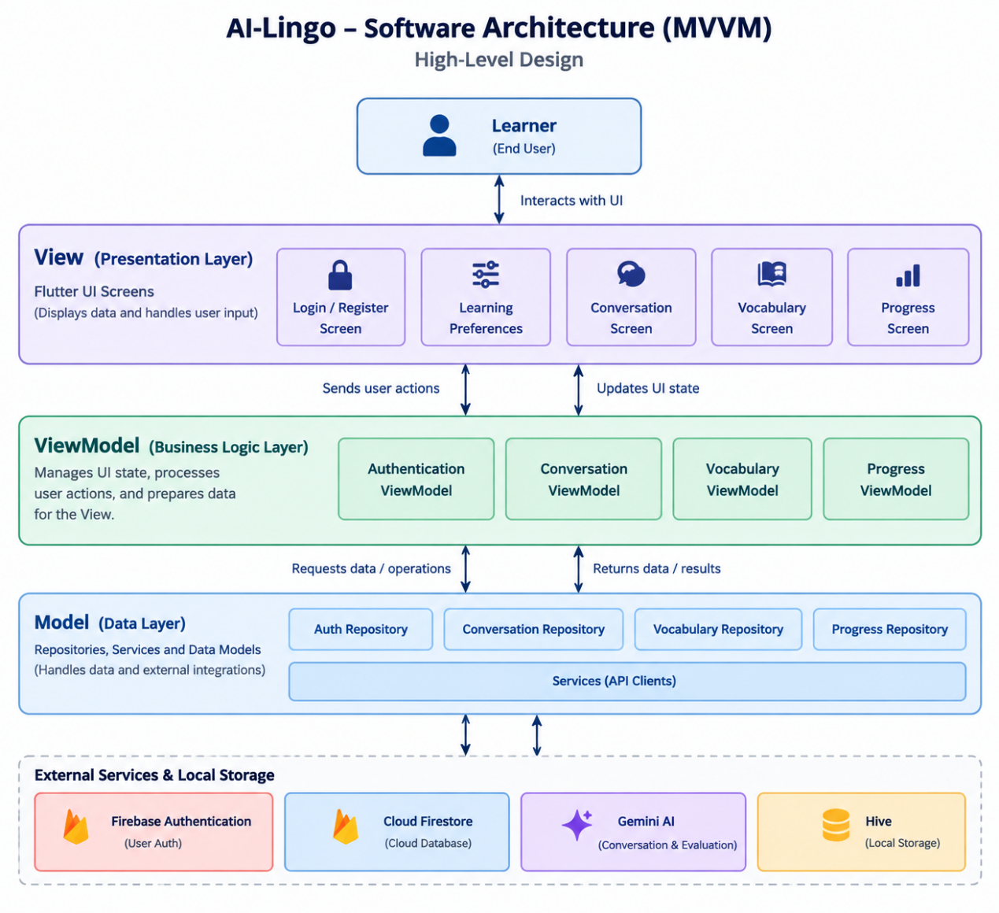
AI-Lingo | Database Design & Data Modeling
1. ER Diagram
Figure 1: AI-Lingo Entity-Relationship Diagram (Chen notation) showing the key and main attributes of each entity.
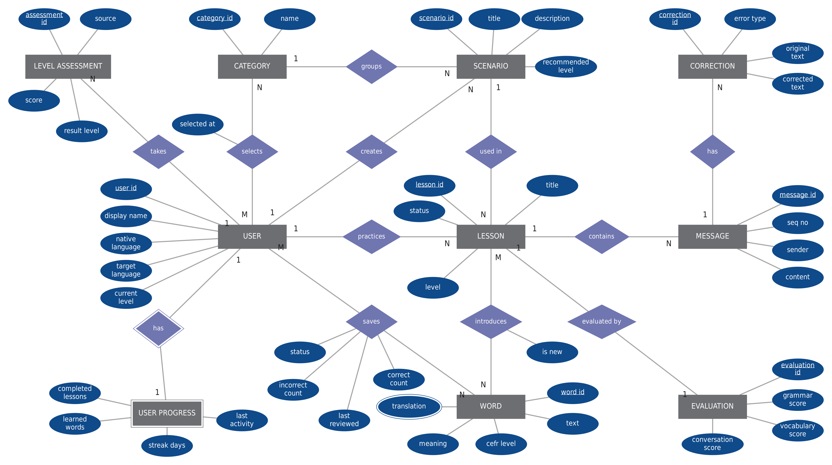
Notation: rectangle = entity (double = weak entity), diamond = relationship, ellipse = attribute (underlined = key, double = multivalued). 1 / N / M = cardinality.

1.1 Relationships
Entity A | Relationship | Entity B | Cardinality (A : B) | Relationship attributes
USER | takes | LEVEL ASSESSMENT | 1 : N
USER | selects | CATEGORY | M : N | selected at
CATEGORY | groups | SCENARIO | 1 : N
USER | creates | SCENARIO | 1 : N | Optional (predefined scenarios have no creator)
USER | practices | LESSON | 1 : N
SCENARIO | used in | LESSON | 1 : N
LESSON | contains | MESSAGE | 1 : N
MESSAGE | has | CORRECTION | 1 : N
LESSON | evaluated by | EVALUATION | 1 : 1
LESSON | introduces | WORD | M : N | is new
USER | saves | WORD | M : N | status, correct count, incorrect count, last reviewed
USER | has | USER PROGRESS | 1 : 1 | Identifying relationship (weak entity)

Mapping to the logical schema: the M:N relationships selects, introduces and saves become the tables USER_INTEREST, LESSON_WORD and USER_WORD, and the multivalued attribute translation becomes the table WORD_TRANSLATION.
2. Logical Schema
Key legend: PK = primary key, FK = foreign key, UQ = unique, UQ* = unique together with the other starred attribute.
USER
A learner account. Profile, learning settings and app preferences (credentials stay in Firebase Authentication).
Attribute | Type | Key | Description
user_id | String | PK | Firebase Authentication UID
display_name | String |  | Name shown in the app
auth_provider | Enum |  | email | google
native_language | String(2) |  | ISO 639-1 code (FR-02)
target_language | String(2) |  | ISO 639-1 code, default 'en'
current_level | Enum |  | CEFR A1–C2, NULL until placement (FR-04, FR-05)
app_language | String(2) |  | Interface language (FR-22)
theme | Enum |  | light | dark | system (FR-22)
notifications_enabled | Boolean |  | Default true (FR-22)
reminder_time | Time |  | Optional daily reminder (FR-18)
created_at | Timestamp |  | Account creation time
last_active_at | Timestamp |  | Last app activity
CATEGORY
A topic area used both as a learner interest and as a scenario category (e.g., Travel, Job Interview, Restaurant).
Attribute | Type | Key | Description
category_id | String | PK | Unique identifier
name | String | UQ | Category name
description | String |  | Short description
USER_INTEREST
Junction table: interests selected by a learner (many-to-many between USER and CATEGORY).
Attribute | Type | Key | Description
user_id | String | PK, FK | References USER
category_id | String | PK, FK | References CATEGORY
selected_at | Timestamp |  | When the interest was chosen
LEVEL_ASSESSMENT
One attempt of the placement test or an automatic level update, kept as history.
Attribute | Type | Key | Description
assessment_id | String | PK | Unique identifier
user_id | String | FK | References USER
source | Enum |  | placement_test | auto_update | manual
status | Enum |  | in_progress | completed
score | Integer |  | 0–100, NULL until completed
result_level | Enum |  | CEFR A1–C2, NULL until completed
started_at | Timestamp |  | Start time
completed_at | Timestamp |  | NULL until completed
SCENARIO
A conversation situation. Predefined scenarios have no creator; custom scenarios belong to a user.
Attribute | Type | Key | Description
scenario_id | String | PK | Unique identifier
category_id | String | FK | References CATEGORY, optional for custom scenarios
created_by | String | FK | References USER; NULL = predefined scenario
title | String |  | Scenario title (FR-06)
description | String |  | Situation description used in the AI prompt
recommended_level | Enum |  | Optional CEFR level
created_at | Timestamp |  | Creation time
LESSON
One AI-generated conversation session for a learner and a scenario. Also serves as the conversation history (FR-19).
Attribute | Type | Key | Description
lesson_id | String | PK | Unique identifier
user_id | String | FK | References USER
scenario_id | String | FK | References SCENARIO
title | String |  | Lesson title
level_at_creation | Enum |  | CEFR level used for generation (FR-07)
status | Enum |  | generated | in_progress | completed
ai_model | String |  | Model name, for traceability
created_at | Timestamp |  | Generation time
completed_at | Timestamp |  | NULL until completed
MESSAGE
One turn in a lesson, written either by the AI or by the learner.
Attribute | Type | Key | Description
message_id | String | PK | Unique identifier
lesson_id | String | FK | References LESSON
seq_no | Integer | UQ* | Order inside the lesson; unique with lesson_id
sender | Enum |  | ai | user
content | Text |  | Message text
created_at | Timestamp |  | Time sent
CORRECTION
A mistake detected in a learner message, with the corrected text and a short explanation (FR-11).
Attribute | Type | Key | Description
correction_id | String | PK | Unique identifier
message_id | String | FK | References MESSAGE (learner messages only)
error_type | Enum |  | grammar | vocabulary
original_text | String |  | Learner's wording
corrected_text | String |  | Suggested wording
explanation | String |  | Short explanation
EVALUATION
AI evaluation of a completed lesson (grammar, vocabulary, and conversation performance).
Attribute | Type | Key | Description
evaluation_id | String | PK | Unique identifier
lesson_id | String | FK, UQ | References LESSON (one evaluation per lesson)
grammar_score | Integer |  | 0–100
vocabulary_score | Integer |  | 0–100
conversation_score | Integer |  | 0–100
feedback_summary | Text |  | General feedback
suggestions | Text |  | Improvement suggestions
created_at | Timestamp |  | Evaluation time
WORD
A dictionary entry shared by all learners.
Attribute | Type | Key | Description
word_id | String | PK | Unique identifier
text | String | UQ* | Lowercase word or phrase; unique with language
language | String(2) | UQ* | ISO 639-1 code of the word
cefr_level | Enum |  | Optional CEFR level
meaning | String |  | Short definition
example_sentence | String |  | Example usage
WORD_TRANSLATION
Translation of a word into a learner's native language (supports new languages without schema change).
Attribute | Type | Key | Description
word_id | String | PK, FK | References WORD
language_code | String(2) | PK | Language of the translation
translation | String |  | Translated text
LESSON_WORD
Junction table: words that appear in a lesson, and whether they were new to the learner (FR-08, FR-09).
Attribute | Type | Key | Description
lesson_id | String | PK, FK | References LESSON
word_id | String | PK, FK | References WORD
is_new | Boolean |  | True if new to the learner when the lesson was generated
USER_WORD
A word saved by a learner, with review history used to mark it as learned (FR-14 to FR-16).
Attribute | Type | Key | Description
user_id | String | PK, FK | References USER
word_id | String | PK, FK | References WORD
source_lesson_id | String | FK | References LESSON, optional
status | Enum |  | new | learning | learned
correct_count | Integer |  | Correct review answers, default 0
incorrect_count | Integer |  | Incorrect review answers, default 0
saved_at | Timestamp |  | When the word was saved
last_reviewed_at | Timestamp |  | NULL until first review
learned_at | Timestamp |  | NULL until marked learned
USER_PROGRESS
Summary counters for the dashboard (one row per learner), stored on purpose to avoid recounting on every screen load.
Attribute | Type | Key | Description
user_id | String | PK, FK | References USER (one-to-one)
completed_lessons | Integer |  | Number of completed lessons (FR-17)
learned_words | Integer |  | Number of words with status 'learned' (FR-17)
streak_days | Integer |  | Current daily streak (FR-18)
last_activity_date | Date |  | Used to calculate the streak
updated_at | Timestamp |  | Last update
2.1 Normalization Considerations
Rule | How the schema applies it
1NF | Every attribute holds a single atomic value. Multi-valued data is moved into separate tables: interests → USER_INTEREST, words in a lesson → LESSON_WORD, saved words → USER_WORD, translations → WORD_TRANSLATION.
2NF | In tables with composite keys (USER_INTEREST, LESSON_WORD, USER_WORD, WORD_TRANSLATION) every non-key attribute depends on the whole key. For example, translation depends on both word_id and language_code, and status depends on both user_id and word_id.
3NF | No non-key attribute depends on another non-key attribute. Word data (meaning, level) lives in WORD, not in USER_WORD; scenario data lives in SCENARIO, not in LESSON; category names live in CATEGORY. The overall evaluation score and the "is custom scenario" flag are not stored because they can be derived (average of three scores; created_by IS NOT NULL).
Domain integrity | CEFR level is restricted to A1–C2 and status/sender/error_type fields to their enum values (CHECK constraints in the logical model; validated in the app and Security Rules in the physical model). Scores are limited to 0–100.
Referential integrity | Every FK references an existing parent row. Deleting a USER cascades to all rows they own (FR-03). Deleting a LESSON cascades to MESSAGE, CORRECTION, EVALUATION, and LESSON_WORD.
Intentional denormalization
Where | What is duplicated or derived | Reason
USER_PROGRESS counters | completed_lessons and learned_words can be calculated by counting LESSON and USER_WORD rows. | Stored to make the dashboard load instantly and work offline (NFR-01, NFR-06). The repository updates them whenever a lesson completes or a word becomes learned.
Firestore embedding (NoSQL) | Firestore has no joins, so related data that is always read together is embedded in one document. | Fewer reads, lower cost and latency (see Section 7.3 for exactly what is embedded).
Vocabulary snapshot | WORD and WORD_TRANSLATION are shared tables logically, but each learner's saved word is stored as one self-contained document. | The vocabulary list loads with a single query and stays readable offline. A word is not shared across users in Firestore.
3. Physical Schema
3.1 Cloud Firestore Structure
categories/{categoryId}
scenarios/{scenarioId}
users/{uid}
├── assessments/{assessmentId}
├── customScenarios/{scenarioId}
├── lessons/{lessonId}
│ └── messages/{messageId}
├── vocabulary/{wordKey}
└── progress/summary

Path | Logical entities | Main fields | Access
categories/{categoryId} | CATEGORY | name, description | Global, read-only for clients
scenarios/{scenarioId} | SCENARIO (predefined) | title, description, categoryId, recommendedLevel | Global, read-only for clients
users/{uid} | USER, USER_INTEREST | displayName, authProvider, nativeLanguage, targetLanguage, currentLevel, interests[ ], settings{ appLanguage, theme, notificationsEnabled, reminderTime }, createdAt, lastActiveAt, updatedAt | Owner only
users/{uid}/assessments/{assessmentId} | LEVEL_ASSESSMENT | source, status, score, resultLevel, startedAt, completedAt | Owner only
users/{uid}/customScenarios/{scenarioId} | SCENARIO (custom) | title, description, categoryId, recommendedLevel, createdAt | Owner only
users/{uid}/lessons/{lessonId} | LESSON, EVALUATION, LESSON_WORD | title, scenario{ id, title, isCustom }, levelAtCreation, status, aiModel, newWords[ { text, meaning, translation } ], evaluation{ grammarScore, vocabularyScore, conversationScore, feedbackSummary, suggestions, createdAt }, createdAt, completedAt | Owner only
users/{uid}/lessons/{lessonId}/messages/{messageId} | MESSAGE, CORRECTION | seqNo, sender, content, corrections[ { errorType, originalText, correctedText, explanation } ], createdAt | Owner only
users/{uid}/vocabulary/{wordKey} | WORD, WORD_TRANSLATION, USER_WORD | text, language, cefrLevel, meaning, exampleSentence, translation, sourceLessonId, status, correctCount, incorrectCount, savedAt, lastReviewedAt, learnedAt, updatedAt | Owner only
users/{uid}/progress/summary | USER_PROGRESS | completedLessons, learnedWords, streakDays, lastActivityDate, updatedAt | Owner only
Embedded logical tables
Logical entity | Physical location | Reason
USER_INTEREST | users/{uid}.interests[ ] | Small list (a few category IDs) always read with the profile.
EVALUATION | lessons/{lessonId}.evaluation | One-to-one with the lesson and read together with it.
LESSON_WORD | lessons/{lessonId}.newWords[ ] | Bounded list, needed to highlight new words (FR-09).
CORRECTION | messages/{messageId}.corrections[ ] | Bounded list belonging to a single message.
WORD + WORD_TRANSLATION + USER_WORD | users/{uid}/vocabulary/{wordKey} | One document per saved word. wordKey is the lowercase word, so a learner cannot save the same word twice.
MESSAGE | Sub-collection of the lesson | Unbounded, loaded separately and ordered by seqNo.
USER_PROGRESS | users/{uid}/progress/summary | Single document, updated after each lesson or review.
Composite indexes
Collection | Index | Used for
lessons | status ASC, createdAt DESC | Show in-progress or completed lessons (history, FR-19)
lessons | createdAt DESC (single field) | Conversation history list
messages | seqNo ASC (single field) | Display a conversation in order
vocabulary | status ASC, savedAt DESC | Vocabulary list filtered by status
vocabulary | status ASC, lastReviewedAt ASC | Pick words that need review (FR-15)
3.2 Local Storage (Hive)
Box | Key | Model (typeId) | Fields | Reqs.
vocabularyBox | wordKey (String) | LocalWord (typeId 1) | text, meaning, translation, exampleSentence, cefrLevel, status, correctCount, incorrectCount, savedAt, lastReviewedAt, learnedAt, updatedAt, syncState | FR-14–16, FR-21
offlineLessonsBox | lessonId (String) | OfflineLesson (typeId 2) with OfflineMessage list (typeId 3) | title, scenarioTitle, level, messages[ { seqNo, sender, content } ], newWords[ ], downloadedAt | FR-20
progressBox | 'summary' (String) | LocalProgress (typeId 4) | completedLessons, learnedWords, streakDays, lastActivityDate, updatedAt | FR-17, FR-21
syncQueueBox | Auto-increment (int) | SyncOperation (typeId 5) | collectionPath, docId, operation (create | update | delete), payload (JSON), createdAt, retryCount | FR-21
settingsBox | Key-value (String) | Primitive values | theme, appLanguage, notificationsEnabled, currentUserId, currentLevel, lastSyncAt | FR-22

AI-Lingo | Database Design & Data Modeling
1. ER Diagram
Figure 1: AI-Lingo Entity-Relationship Diagram (crow's foot notation). Each entity shows its primary key (PK), foreign keys (FK), and main attributes.
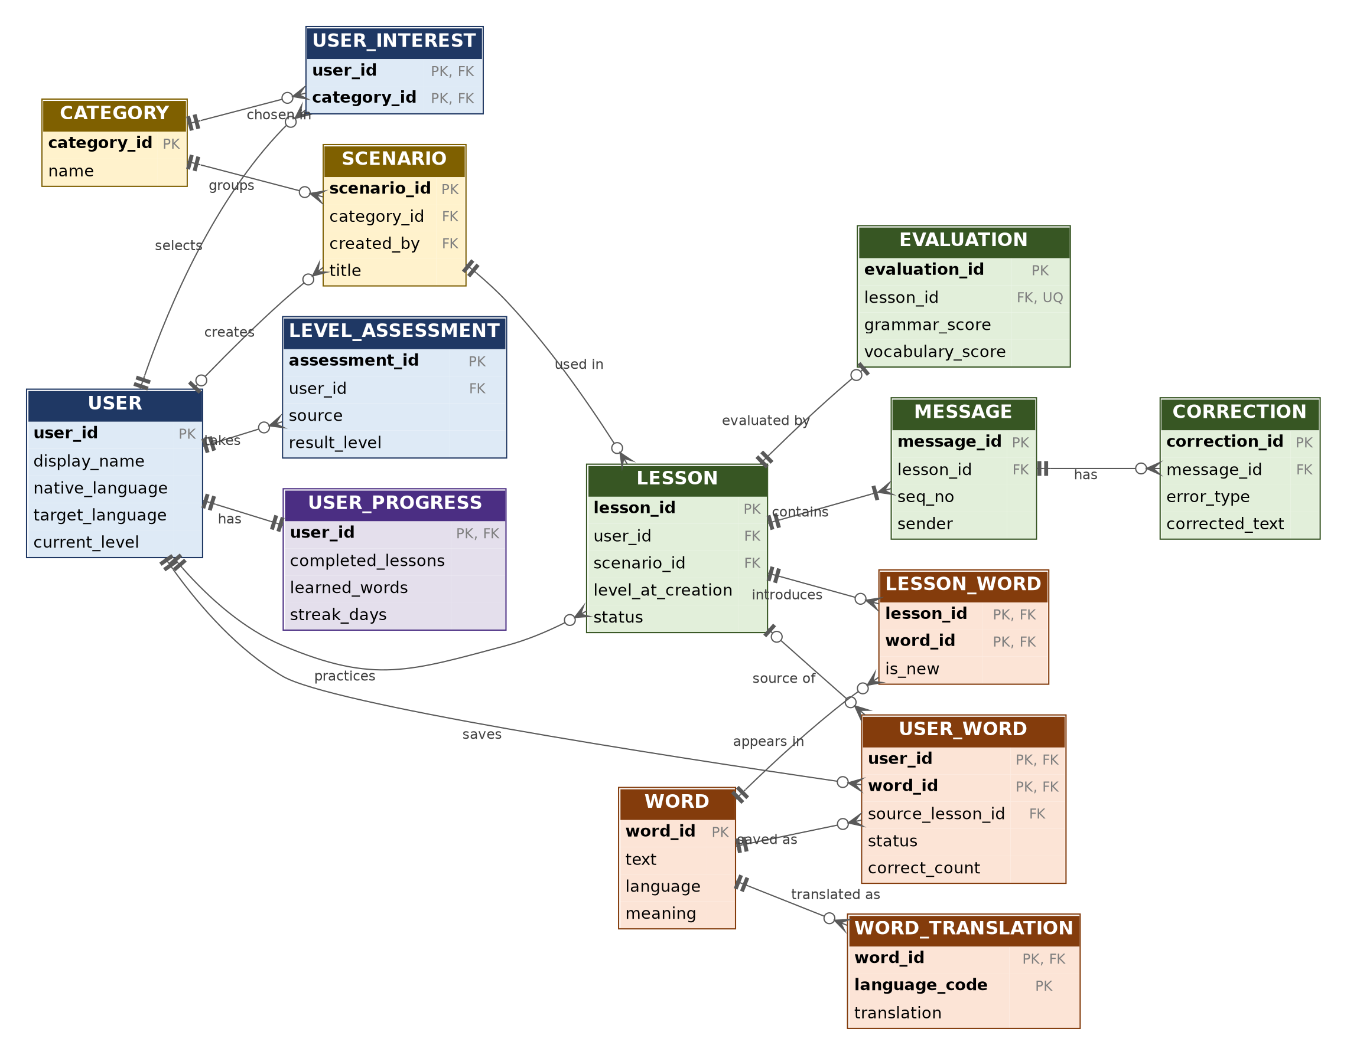
Notation: || exactly one |o zero or one o< zero or many |< one or many. Colors: blue = users, yellow = catalog, green = learning, orange = vocabulary, purple = progress.

1.1 Relationships
Parent | Child | Cardinality (parent : child) | Meaning
USER | LEVEL_ASSESSMENT | 1 : 0..N | takes
USER | USER_INTEREST | 1 : 0..N | selects
CATEGORY | USER_INTEREST | 1 : 0..N | chosen in
CATEGORY | SCENARIO | 1 : 0..N | groups
USER | SCENARIO | 0..1 : 0..N | creates
USER | LESSON | 1 : 0..N | practices
SCENARIO | LESSON | 1 : 0..N | used in
LESSON | MESSAGE | 1 : 1..N | contains
MESSAGE | CORRECTION | 1 : 0..N | has
LESSON | EVALUATION | 1 : 0..1 | evaluated by
LESSON | LESSON_WORD | 1 : 0..N | introduces
WORD | LESSON_WORD | 1 : 0..N | appears in
WORD | WORD_TRANSLATION | 1 : 0..N | translated as
USER | USER_WORD | 1 : 0..N | saves
WORD | USER_WORD | 1 : 0..N | saved as
LESSON | USER_WORD | 0..1 : 0..N | source of
USER | USER_PROGRESS | 1 : 1 | has
2. Logical Schema
Key legend: PK = primary key, FK = foreign key, UQ = unique, UQ* = unique together with the other starred attribute.
USER
A learner account. Profile, learning settings and app preferences (credentials stay in Firebase Authentication).
Attribute | Type | Key | Description
user_id | String | PK | Firebase Authentication UID
display_name | String |  | Name shown in the app
auth_provider | Enum |  | email | google
native_language | String(2) |  | ISO 639-1 code (FR-02)
target_language | String(2) |  | ISO 639-1 code, default 'en'
current_level | Enum |  | CEFR A1–C2, NULL until placement (FR-04, FR-05)
app_language | String(2) |  | Interface language (FR-22)
theme | Enum |  | light | dark | system (FR-22)
notifications_enabled | Boolean |  | Default true (FR-22)
reminder_time | Time |  | Optional daily reminder (FR-18)
created_at | Timestamp |  | Account creation time
last_active_at | Timestamp |  | Last app activity
CATEGORY
A topic area used both as a learner interest and as a scenario category (e.g., Travel, Job Interview, Restaurant).
Attribute | Type | Key | Description
category_id | String | PK | Unique identifier
name | String | UQ | Category name
description | String |  | Short description
USER_INTEREST
Junction table: interests selected by a learner (many-to-many between USER and CATEGORY).
Attribute | Type | Key | Description
user_id | String | PK, FK | References USER
category_id | String | PK, FK | References CATEGORY
selected_at | Timestamp |  | When the interest was chosen
LEVEL_ASSESSMENT
One attempt of the placement test or an automatic level update, kept as history.
Attribute | Type | Key | Description
assessment_id | String | PK | Unique identifier
user_id | String | FK | References USER
source | Enum |  | placement_test | auto_update | manual
status | Enum |  | in_progress | completed
score | Integer |  | 0–100, NULL until completed
result_level | Enum |  | CEFR A1–C2, NULL until completed
started_at | Timestamp |  | Start time
completed_at | Timestamp |  | NULL until completed
SCENARIO
A conversation situation. Predefined scenarios have no creator; custom scenarios belong to a user.
Attribute | Type | Key | Description
scenario_id | String | PK | Unique identifier
category_id | String | FK | References CATEGORY, optional for custom scenarios
created_by | String | FK | References USER; NULL = predefined scenario
title | String |  | Scenario title (FR-06)
description | String |  | Situation description used in the AI prompt
recommended_level | Enum |  | Optional CEFR level
created_at | Timestamp |  | Creation time
LESSON
One AI-generated conversation session for a learner and a scenario. Also serves as the conversation history (FR-19).
Attribute | Type | Key | Description
lesson_id | String | PK | Unique identifier
user_id | String | FK | References USER
scenario_id | String | FK | References SCENARIO
title | String |  | Lesson title
level_at_creation | Enum |  | CEFR level used for generation (FR-07)
status | Enum |  | generated | in_progress | completed
ai_model | String |  | Model name, for traceability
created_at | Timestamp |  | Generation time
completed_at | Timestamp |  | NULL until completed
MESSAGE
One turn in a lesson, written either by the AI or by the learner.
Attribute | Type | Key | Description
message_id | String | PK | Unique identifier
lesson_id | String | FK | References LESSON
seq_no | Integer | UQ* | Order inside the lesson; unique with lesson_id
sender | Enum |  | ai | user
content | Text |  | Message text
created_at | Timestamp |  | Time sent
CORRECTION
A mistake detected in a learner message, with the corrected text and a short explanation (FR-11).
Attribute | Type | Key | Description
correction_id | String | PK | Unique identifier
message_id | String | FK | References MESSAGE (learner messages only)
error_type | Enum |  | grammar | vocabulary
original_text | String |  | Learner's wording
corrected_text | String |  | Suggested wording
explanation | String |  | Short explanation
EVALUATION
AI evaluation of a completed lesson (grammar, vocabulary, and conversation performance).
Attribute | Type | Key | Description
evaluation_id | String | PK | Unique identifier
lesson_id | String | FK, UQ | References LESSON (one evaluation per lesson)
grammar_score | Integer |  | 0–100
vocabulary_score | Integer |  | 0–100
conversation_score | Integer |  | 0–100
feedback_summary | Text |  | General feedback
suggestions | Text |  | Improvement suggestions
created_at | Timestamp |  | Evaluation time
WORD
A dictionary entry shared by all learners.
Attribute | Type | Key | Description
word_id | String | PK | Unique identifier
text | String | UQ* | Lowercase word or phrase; unique with language
language | String(2) | UQ* | ISO 639-1 code of the word
cefr_level | Enum |  | Optional CEFR level
meaning | String |  | Short definition
example_sentence | String |  | Example usage
WORD_TRANSLATION
Translation of a word into a learner's native language (supports new languages without schema change).
Attribute | Type | Key | Description
word_id | String | PK, FK | References WORD
language_code | String(2) | PK | Language of the translation
translation | String |  | Translated text
LESSON_WORD
Junction table: words that appear in a lesson, and whether they were new to the learner (FR-08, FR-09).
Attribute | Type | Key | Description
lesson_id | String | PK, FK | References LESSON
word_id | String | PK, FK | References WORD
is_new | Boolean |  | True if new to the learner when the lesson was generated
USER_WORD
A word saved by a learner, with review history used to mark it as learned (FR-14 to FR-16).
Attribute | Type | Key | Description
user_id | String | PK, FK | References USER
word_id | String | PK, FK | References WORD
source_lesson_id | String | FK | References LESSON, optional
status | Enum |  | new | learning | learned
correct_count | Integer |  | Correct review answers, default 0
incorrect_count | Integer |  | Incorrect review answers, default 0
saved_at | Timestamp |  | When the word was saved
last_reviewed_at | Timestamp |  | NULL until first review
learned_at | Timestamp |  | NULL until marked learned
USER_PROGRESS
Summary counters for the dashboard (one row per learner), stored on purpose to avoid recounting on every screen load.
Attribute | Type | Key | Description
user_id | String | PK, FK | References USER (one-to-one)
completed_lessons | Integer |  | Number of completed lessons (FR-17)
learned_words | Integer |  | Number of words with status 'learned' (FR-17)
streak_days | Integer |  | Current daily streak (FR-18)
last_activity_date | Date |  | Used to calculate the streak
updated_at | Timestamp |  | Last update
2.1 Normalization Considerations
Rule | How the schema applies it
1NF | Every attribute holds a single atomic value. Multi-valued data is moved into separate tables: interests → USER_INTEREST, words in a lesson → LESSON_WORD, saved words → USER_WORD, translations → WORD_TRANSLATION.
2NF | In tables with composite keys (USER_INTEREST, LESSON_WORD, USER_WORD, WORD_TRANSLATION) every non-key attribute depends on the whole key. For example, translation depends on both word_id and language_code, and status depends on both user_id and word_id.
3NF | No non-key attribute depends on another non-key attribute. Word data (meaning, level) lives in WORD, not in USER_WORD; scenario data lives in SCENARIO, not in LESSON; category names live in CATEGORY. The overall evaluation score and the "is custom scenario" flag are not stored because they can be derived (average of three scores; created_by IS NOT NULL).
Domain integrity | CEFR level is restricted to A1–C2 and status/sender/error_type fields to their enum values (CHECK constraints in the logical model; validated in the app and Security Rules in the physical model). Scores are limited to 0–100.
Referential integrity | Every FK references an existing parent row. Deleting a USER cascades to all rows they own (FR-03). Deleting a LESSON cascades to MESSAGE, CORRECTION, EVALUATION, and LESSON_WORD.
Intentional denormalization
Where | What is duplicated or derived | Reason
USER_PROGRESS counters | completed_lessons and learned_words can be calculated by counting LESSON and USER_WORD rows. | Stored to make the dashboard load instantly and work offline (NFR-01, NFR-06). The repository updates them whenever a lesson completes or a word becomes learned.
Firestore embedding (NoSQL) | Firestore has no joins, so related data that is always read together is embedded in one document. | Fewer reads, lower cost and latency (see Section 7.3 for exactly what is embedded).
Vocabulary snapshot | WORD and WORD_TRANSLATION are shared tables logically, but each learner's saved word is stored as one self-contained document. | The vocabulary list loads with a single query and stays readable offline. A word is not shared across users in Firestore.
3. Physical Schema
3.1 Cloud Firestore Structure
categories/{categoryId}
scenarios/{scenarioId}
users/{uid}
├── assessments/{assessmentId}
├── customScenarios/{scenarioId}
├── lessons/{lessonId}
│ └── messages/{messageId}
├── vocabulary/{wordKey}
└── progress/summary

Path | Logical entities | Main fields | Access
categories/{categoryId} | CATEGORY | name, description | Global, read-only for clients
scenarios/{scenarioId} | SCENARIO (predefined) | title, description, categoryId, recommendedLevel | Global, read-only for clients
users/{uid} | USER, USER_INTEREST | displayName, authProvider, nativeLanguage, targetLanguage, currentLevel, interests[ ], settings{ appLanguage, theme, notificationsEnabled, reminderTime }, createdAt, lastActiveAt, updatedAt | Owner only
users/{uid}/assessments/{assessmentId} | LEVEL_ASSESSMENT | source, status, score, resultLevel, startedAt, completedAt | Owner only
users/{uid}/customScenarios/{scenarioId} | SCENARIO (custom) | title, description, categoryId, recommendedLevel, createdAt | Owner only
users/{uid}/lessons/{lessonId} | LESSON, EVALUATION, LESSON_WORD | title, scenario{ id, title, isCustom }, levelAtCreation, status, aiModel, newWords[ { text, meaning, translation } ], evaluation{ grammarScore, vocabularyScore, conversationScore, feedbackSummary, suggestions, createdAt }, createdAt, completedAt | Owner only
users/{uid}/lessons/{lessonId}/messages/{messageId} | MESSAGE, CORRECTION | seqNo, sender, content, corrections[ { errorType, originalText, correctedText, explanation } ], createdAt | Owner only
users/{uid}/vocabulary/{wordKey} | WORD, WORD_TRANSLATION, USER_WORD | text, language, cefrLevel, meaning, exampleSentence, translation, sourceLessonId, status, correctCount, incorrectCount, savedAt, lastReviewedAt, learnedAt, updatedAt | Owner only
users/{uid}/progress/summary | USER_PROGRESS | completedLessons, learnedWords, streakDays, lastActivityDate, updatedAt | Owner only
Embedded logical tables
Logical entity | Physical location | Reason
USER_INTEREST | users/{uid}.interests[ ] | Small list (a few category IDs) always read with the profile.
EVALUATION | lessons/{lessonId}.evaluation | One-to-one with the lesson and read together with it.
LESSON_WORD | lessons/{lessonId}.newWords[ ] | Bounded list, needed to highlight new words (FR-09).
CORRECTION | messages/{messageId}.corrections[ ] | Bounded list belonging to a single message.
WORD + WORD_TRANSLATION + USER_WORD | users/{uid}/vocabulary/{wordKey} | One document per saved word. wordKey is the lowercase word, so a learner cannot save the same word twice.
MESSAGE | Sub-collection of the lesson | Unbounded, loaded separately and ordered by seqNo.
USER_PROGRESS | users/{uid}/progress/summary | Single document, updated after each lesson or review.
Composite indexes
Collection | Index | Used for
lessons | status ASC, createdAt DESC | Show in-progress or completed lessons (history, FR-19)
lessons | createdAt DESC (single field) | Conversation history list
messages | seqNo ASC (single field) | Display a conversation in order
vocabulary | status ASC, savedAt DESC | Vocabulary list filtered by status
vocabulary | status ASC, lastReviewedAt ASC | Pick words that need review (FR-15)
3.2 Local Storage (Hive)
Box | Key | Model (typeId) | Fields | Reqs.
vocabularyBox | wordKey (String) | LocalWord (typeId 1) | text, meaning, translation, exampleSentence, cefrLevel, status, correctCount, incorrectCount, savedAt, lastReviewedAt, learnedAt, updatedAt, syncState | FR-14–16, FR-21
offlineLessonsBox | lessonId (String) | OfflineLesson (typeId 2) with OfflineMessage list (typeId 3) | title, scenarioTitle, level, messages[ { seqNo, sender, content } ], newWords[ ], downloadedAt | FR-20
progressBox | 'summary' (String) | LocalProgress (typeId 4) | completedLessons, learnedWords, streakDays, lastActivityDate, updatedAt | FR-17, FR-21
syncQueueBox | Auto-increment (int) | SyncOperation (typeId 5) | collectionPath, docId, operation (create | update | delete), payload (JSON), createdAt, retryCount | FR-21
settingsBox | Key-value (String) | Primitive values | theme, appLanguage, notificationsEnabled, currentUserId, currentLevel, lastSyncAt | FR-22

AI-Lingo
Contextual Language Immersion App
Database Design & Data Modeling
1. Introduction
This document describes the database design for AI-Lingo, a Flutter mobile application that generates AI-based English conversations, evaluates the learner's responses, manages vocabulary, and tracks progress. It contains the ER diagram, the logical schema (tables, attributes, keys, and normalization), and the physical schema for the two storage technologies used by the project: Cloud Firestore and Hive.
The design is based on the project plan, the functional requirements (FR-01 to FR-22), the non-functional requirements, and the System Analysis & Design document (use cases UC-01 to UC-09 and the MVVM architecture).
1.1 Design Approach
- Logical first: The logical model is relational (entities, keys, and normalization) so that the data structure is clear and consistent.
- Physical second: Firestore and Hive are NoSQL stores, so the physical model maps the logical tables to collections, documents, and boxes, embedding data that is read together.
- Privacy by design: every learner's data is private and stored under users/{uid}; only the minimum data needed for the learning features is kept.
- Extensible: new scenarios, categories, and languages are added as data, not as schema changes (NFR-08).
2. Data Storage Strategy
Store | What it holds | Why
Firebase Authentication | Accounts and credentials (email/password, Google) | Secure credential handling; no passwords in our database
Cloud Firestore | Source of truth for each learner's profile, lessons, messages, vocabulary, and progress | Cloud backup and sync across devices (FR-11, FR-21)
Hive (encrypted) | Local copy of vocabulary and progress, downloaded lessons, sync queue, and settings | Offline access and fast loading (NFR-01, NFR-06)
Gemini (Firebase AI Logic) | Not a database: generates dialogues and evaluations; results are saved to Firestore/Hive | No API key in the app; only necessary data is sent (NFR-03, NFR-09)

The Model layer of the MVVM architecture reaches these stores through four repositories:
Repository | Data sources
Auth Repository | Firebase Authentication, users/{uid}
Conversation Repository | Gemini, lessons, messages, scenarios, assessments, offlineLessonsBox
Vocabulary Repository | users/{uid}/vocabulary, vocabularyBox, syncQueueBox
Progress Repository | users/{uid}/progress/summary, progressBox
3. Entity Identification
The model contains 14 entities, grouped by color in the ER diagram.
Entity | Group | Description
USER | Users & Profile | A learner account. Profile, learning settings and app preferences (credentials stay in Firebase Authentication).
CATEGORY | Catalog | A topic area used both as a learner interest and as a scenario category (e.g., Travel, Job Interview, Restaurant).
USER_INTEREST | Users & Profile | Junction table: interests selected by a learner (many-to-many between USER and CATEGORY).
LEVEL_ASSESSMENT | Users & Profile | One attempt of the placement test or an automatic level update, kept as history.
SCENARIO | Catalog | A conversation situation. Predefined scenarios have no creator; custom scenarios belong to a user.
LESSON | Learning | One AI-generated conversation session for a learner and a scenario. Also serves as the conversation history (FR-19).
MESSAGE | Learning | One turn in a lesson, written either by the AI or by the learner.
CORRECTION | Learning | A mistake detected in a learner message, with the corrected text and a short explanation (FR-11).
EVALUATION | Learning | AI evaluation of a completed lesson (grammar, vocabulary, and conversation performance).
WORD | Vocabulary | A dictionary entry shared by all learners.
WORD_TRANSLATION | Vocabulary | Translation of a word into a learner's native language (supports new languages without schema change).
LESSON_WORD | Vocabulary | Junction table: words that appear in a lesson, and whether they were new to the learner (FR-08, FR-09).
USER_WORD | Vocabulary | A word saved by a learner, with review history used to mark it as learned (FR-14 to FR-16).
USER_PROGRESS | Progress | Summary counters for the dashboard (one row per learner), stored on purpose to avoid recounting on every screen load.

4. ER Diagram
Each entity shows its primary key (PK), foreign keys (FK), and main attributes. The complete attribute list is in Section 5.
Figure 1: AI-Lingo Entity-Relationship Diagram (crow's foot notation)
Notation: || exactly one |o zero or one o< zero or many |< one or many. Colors: blue = users, yellow = catalog, green = learning, orange = vocabulary, purple = progress.

4.1 Relationships
Parent | Child | Cardinality (parent : child) | Meaning
USER | LEVEL_ASSESSMENT | 1 : 0..N | takes
USER | USER_INTEREST | 1 : 0..N | selects
CATEGORY | USER_INTEREST | 1 : 0..N | chosen in
CATEGORY | SCENARIO | 1 : 0..N | groups
USER | SCENARIO | 0..1 : 0..N | creates
USER | LESSON | 1 : 0..N | practices
SCENARIO | LESSON | 1 : 0..N | used in
LESSON | MESSAGE | 1 : 1..N | contains
MESSAGE | CORRECTION | 1 : 0..N | has
LESSON | EVALUATION | 1 : 0..1 | evaluated by
LESSON | LESSON_WORD | 1 : 0..N | introduces
WORD | LESSON_WORD | 1 : 0..N | appears in
WORD | WORD_TRANSLATION | 1 : 0..N | translated as
USER | USER_WORD | 1 : 0..N | saves
WORD | USER_WORD | 1 : 0..N | saved as
LESSON | USER_WORD | 0..1 : 0..N | source of
USER | USER_PROGRESS | 1 : 1 | has

Key design decisions
- One category list: Interests and scenario categories use the same CATEGORY table, so a learner's interests directly filter the scenario list.
- Lesson = conversation: LESSON is one AI conversation session, so it also serves as the history of past conversations (FR-19).
- Predefined and custom scenarios in one table: created_by is NULL for predefined scenarios and holds the user ID for custom ones (FR-06).
- Words are shared: USER_WORD links a learner to a shared WORD, and LESSON_WORD links lessons to words, which makes new-word highlighting and auto-save simple (FR-08, FR-09, FR-14).
- Level history: LEVEL_ASSESSMENT keeps the placement test and later automatic updates as history, while USER.current_level holds the latest level.
5. Logical Schema
Key legend: PK = primary key, FK = foreign key, UQ = unique, UQ* = unique together with the other starred attribute. Types are logical types; Firestore and Hive types are given in Section 7.
USER
A learner account. Profile, learning settings and app preferences (credentials stay in Firebase Authentication).
Attribute | Type | Key | Description
user_id | String | PK | Firebase Authentication UID
display_name | String |  | Name shown in the app
auth_provider | Enum |  | email | google
native_language | String(2) |  | ISO 639-1 code (FR-02)
target_language | String(2) |  | ISO 639-1 code, default 'en'
current_level | Enum |  | CEFR A1–C2, NULL until placement (FR-04, FR-05)
app_language | String(2) |  | Interface language (FR-22)
theme | Enum |  | light | dark | system (FR-22)
notifications_enabled | Boolean |  | Default true (FR-22)
reminder_time | Time |  | Optional daily reminder (FR-18)
created_at | Timestamp |  | Account creation time
last_active_at | Timestamp |  | Last app activity
CATEGORY
A topic area used both as a learner interest and as a scenario category (e.g., Travel, Job Interview, Restaurant).
Attribute | Type | Key | Description
category_id | String | PK | Unique identifier
name | String | UQ | Category name
description | String |  | Short description
USER_INTEREST
Junction table: interests selected by a learner (many-to-many between USER and CATEGORY).
Attribute | Type | Key | Description
user_id | String | PK, FK | References USER
category_id | String | PK, FK | References CATEGORY
selected_at | Timestamp |  | When the interest was chosen
LEVEL_ASSESSMENT
One attempt of the placement test or an automatic level update, kept as history.
Attribute | Type | Key | Description
assessment_id | String | PK | Unique identifier
user_id | String | FK | References USER
source | Enum |  | placement_test | auto_update | manual
status | Enum |  | in_progress | completed
score | Integer |  | 0–100, NULL until completed
result_level | Enum |  | CEFR A1–C2, NULL until completed
started_at | Timestamp |  | Start time
completed_at | Timestamp |  | NULL until completed
SCENARIO
A conversation situation. Predefined scenarios have no creator; custom scenarios belong to a user.
Attribute | Type | Key | Description
scenario_id | String | PK | Unique identifier
category_id | String | FK | References CATEGORY, optional for custom scenarios
created_by | String | FK | References USER; NULL = predefined scenario
title | String |  | Scenario title (FR-06)
description | String |  | Situation description used in the AI prompt
recommended_level | Enum |  | Optional CEFR level
created_at | Timestamp |  | Creation time
LESSON
One AI-generated conversation session for a learner and a scenario. Also serves as the conversation history (FR-19).
Attribute | Type | Key | Description
lesson_id | String | PK | Unique identifier
user_id | String | FK | References USER
scenario_id | String | FK | References SCENARIO
title | String |  | Lesson title
level_at_creation | Enum |  | CEFR level used for generation (FR-07)
status | Enum |  | generated | in_progress | completed
ai_model | String |  | Model name, for traceability
created_at | Timestamp |  | Generation time
completed_at | Timestamp |  | NULL until completed
MESSAGE
One turn in a lesson, written either by the AI or by the learner.
Attribute | Type | Key | Description
message_id | String | PK | Unique identifier
lesson_id | String | FK | References LESSON
seq_no | Integer | UQ* | Order inside the lesson; unique with lesson_id
sender | Enum |  | ai | user
content | Text |  | Message text
created_at | Timestamp |  | Time sent
CORRECTION
A mistake detected in a learner message, with the corrected text and a short explanation (FR-11).
Attribute | Type | Key | Description
correction_id | String | PK | Unique identifier
message_id | String | FK | References MESSAGE (learner messages only)
error_type | Enum |  | grammar | vocabulary
original_text | String |  | Learner's wording
corrected_text | String |  | Suggested wording
explanation | String |  | Short explanation
EVALUATION
AI evaluation of a completed lesson (grammar, vocabulary, and conversation performance).
Attribute | Type | Key | Description
evaluation_id | String | PK | Unique identifier
lesson_id | String | FK, UQ | References LESSON (one evaluation per lesson)
grammar_score | Integer |  | 0–100
vocabulary_score | Integer |  | 0–100
conversation_score | Integer |  | 0–100
feedback_summary | Text |  | General feedback
suggestions | Text |  | Improvement suggestions
created_at | Timestamp |  | Evaluation time
WORD
A dictionary entry shared by all learners.
Attribute | Type | Key | Description
word_id | String | PK | Unique identifier
text | String | UQ* | Lowercase word or phrase; unique with language
language | String(2) | UQ* | ISO 639-1 code of the word
cefr_level | Enum |  | Optional CEFR level
meaning | String |  | Short definition
example_sentence | String |  | Example usage
WORD_TRANSLATION
Translation of a word into a learner's native language (supports new languages without schema change).
Attribute | Type | Key | Description
word_id | String | PK, FK | References WORD
language_code | String(2) | PK | Language of the translation
translation | String |  | Translated text
LESSON_WORD
Junction table: words that appear in a lesson, and whether they were new to the learner (FR-08, FR-09).
Attribute | Type | Key | Description
lesson_id | String | PK, FK | References LESSON
word_id | String | PK, FK | References WORD
is_new | Boolean |  | True if new to the learner when the lesson was generated
USER_WORD
A word saved by a learner, with review history used to mark it as learned (FR-14 to FR-16).
Attribute | Type | Key | Description
user_id | String | PK, FK | References USER
word_id | String | PK, FK | References WORD
source_lesson_id | String | FK | References LESSON, optional
status | Enum |  | new | learning | learned
correct_count | Integer |  | Correct review answers, default 0
incorrect_count | Integer |  | Incorrect review answers, default 0
saved_at | Timestamp |  | When the word was saved
last_reviewed_at | Timestamp |  | NULL until first review
learned_at | Timestamp |  | NULL until marked learned
USER_PROGRESS
Summary counters for the dashboard (one row per learner), stored on purpose to avoid recounting on every screen load.
Attribute | Type | Key | Description
user_id | String | PK, FK | References USER (one-to-one)
completed_lessons | Integer |  | Number of completed lessons (FR-17)
learned_words | Integer |  | Number of words with status 'learned' (FR-17)
streak_days | Integer |  | Current daily streak (FR-18)
last_activity_date | Date |  | Used to calculate the streak
updated_at | Timestamp |  | Last update
6. Normalization Considerations
Rule | How the schema applies it
1NF | Every attribute holds a single atomic value. Multi-valued data is moved into separate tables: interests → USER_INTEREST, words in a lesson → LESSON_WORD, saved words → USER_WORD, translations → WORD_TRANSLATION.
2NF | In tables with composite keys (USER_INTEREST, LESSON_WORD, USER_WORD, WORD_TRANSLATION) every non-key attribute depends on the whole key. For example, translation depends on both word_id and language_code, and status depends on both user_id and word_id.
3NF | No non-key attribute depends on another non-key attribute. Word data (meaning, level) lives in WORD, not in USER_WORD; scenario data lives in SCENARIO, not in LESSON; category names live in CATEGORY. The overall evaluation score and the "is custom scenario" flag are not stored because they can be derived (average of three scores; created_by IS NOT NULL).
Domain integrity | CEFR level is restricted to A1–C2 and status/sender/error_type fields to their enum values (CHECK constraints in the logical model; validated in the app and Security Rules in the physical model). Scores are limited to 0–100.
Referential integrity | Every FK references an existing parent row. Deleting a USER cascades to all rows they own (FR-03). Deleting a LESSON cascades to MESSAGE, CORRECTION, EVALUATION, and LESSON_WORD.
6.1 Intentional Denormalization
Where | What is duplicated or derived | Reason
USER_PROGRESS counters | completed_lessons and learned_words can be calculated by counting LESSON and USER_WORD rows. | Stored to make the dashboard load instantly and work offline (NFR-01, NFR-06). The repository updates them whenever a lesson completes or a word becomes learned.
Firestore embedding (NoSQL) | Firestore has no joins, so related data that is always read together is embedded in one document. | Fewer reads, lower cost and latency (see Section 7.3 for exactly what is embedded).
Vocabulary snapshot | WORD and WORD_TRANSLATION are shared tables logically, but each learner's saved word is stored as one self-contained document. | The vocabulary list loads with a single query and stays readable offline. A word is not shared across users in Firestore.
7. Physical Schema
7.1 Cloud Firestore Structure
Cloud Firestore stores each learner's data under their own document. Field names use camelCase; timestamps use the Firestore Timestamp type.
categories/{categoryId}
scenarios/{scenarioId}
users/{uid}
├── assessments/{assessmentId}
├── customScenarios/{scenarioId}
├── lessons/{lessonId}
│ └── messages/{messageId}
├── vocabulary/{wordKey}
└── progress/summary

Path | Logical entities | Main fields | Access
categories/{categoryId} | CATEGORY | name, description | Global, read-only for clients
scenarios/{scenarioId} | SCENARIO (predefined) | title, description, categoryId, recommendedLevel | Global, read-only for clients
users/{uid} | USER, USER_INTEREST | displayName, authProvider, nativeLanguage, targetLanguage, currentLevel, interests[ ], settings{ appLanguage, theme, notificationsEnabled, reminderTime }, createdAt, lastActiveAt, updatedAt | Owner only
users/{uid}/assessments/{assessmentId} | LEVEL_ASSESSMENT | source, status, score, resultLevel, startedAt, completedAt | Owner only
users/{uid}/customScenarios/{scenarioId} | SCENARIO (custom) | title, description, categoryId, recommendedLevel, createdAt | Owner only
users/{uid}/lessons/{lessonId} | LESSON, EVALUATION, LESSON_WORD | title, scenario{ id, title, isCustom }, levelAtCreation, status, aiModel, newWords[ { text, meaning, translation } ], evaluation{ grammarScore, vocabularyScore, conversationScore, feedbackSummary, suggestions, createdAt }, createdAt, completedAt | Owner only
users/{uid}/lessons/{lessonId}/messages/{messageId} | MESSAGE, CORRECTION | seqNo, sender, content, corrections[ { errorType, originalText, correctedText, explanation } ], createdAt | Owner only
users/{uid}/vocabulary/{wordKey} | WORD, WORD_TRANSLATION, USER_WORD | text, language, cefrLevel, meaning, exampleSentence, translation, sourceLessonId, status, correctCount, incorrectCount, savedAt, lastReviewedAt, learnedAt, updatedAt | Owner only
users/{uid}/progress/summary | USER_PROGRESS | completedLessons, learnedWords, streakDays, lastActivityDate, updatedAt | Owner only
7.2 Composite Indexes
Collection | Index | Used for
lessons | status ASC, createdAt DESC | Show in-progress or completed lessons (history, FR-19)
lessons | createdAt DESC (single field) | Conversation history list
messages | seqNo ASC (single field) | Display a conversation in order
vocabulary | status ASC, savedAt DESC | Vocabulary list filtered by status
vocabulary | status ASC, lastReviewedAt ASC | Pick words that need review (FR-15)
7.3 How Logical Tables Are Embedded
Logical entity | Physical location | Reason
USER_INTEREST | users/{uid}.interests[ ] | Small list (a few category IDs) always read with the profile.
EVALUATION | lessons/{lessonId}.evaluation | One-to-one with the lesson and read together with it.
LESSON_WORD | lessons/{lessonId}.newWords[ ] | Bounded list, needed to highlight new words (FR-09).
CORRECTION | messages/{messageId}.corrections[ ] | Bounded list belonging to a single message.
WORD + WORD_TRANSLATION + USER_WORD | users/{uid}/vocabulary/{wordKey} | One document per saved word. wordKey is the lowercase word, so a learner cannot save the same word twice.
MESSAGE | Sub-collection of the lesson | Unbounded, loaded separately and ordered by seqNo.
USER_PROGRESS | users/{uid}/progress/summary | Single document, updated after each lesson or review.
7.4 Local Storage (Hive)
Hive stores a local copy of the data that must work offline. All boxes are opened with HiveAesCipher; the encryption key is generated once and kept in Android Keystore through flutter_secure_storage. Data is cleared from the device when the learner logs out.
Box | Key | Model (typeId) | Fields | Reqs.
vocabularyBox | wordKey (String) | LocalWord (typeId 1) | text, meaning, translation, exampleSentence, cefrLevel, status, correctCount, incorrectCount, savedAt, lastReviewedAt, learnedAt, updatedAt, syncState | FR-14–16, FR-21
offlineLessonsBox | lessonId (String) | OfflineLesson (typeId 2) with OfflineMessage list (typeId 3) | title, scenarioTitle, level, messages[ { seqNo, sender, content } ], newWords[ ], downloadedAt | FR-20
progressBox | 'summary' (String) | LocalProgress (typeId 4) | completedLessons, learnedWords, streakDays, lastActivityDate, updatedAt | FR-17, FR-21
syncQueueBox | Auto-increment (int) | SyncOperation (typeId 5) | collectionPath, docId, operation (create | update | delete), payload (JSON), createdAt, retryCount | FR-21
settingsBox | Key-value (String) | Primitive values | theme, appLanguage, notificationsEnabled, currentUserId, currentLevel, lastSyncAt | FR-22

syncState values in vocabularyBox: synced | pending. Every local change also adds a SyncOperation to syncQueueBox.
7.5 Synchronization Rules
- Offline-first writes: write to Hive first, add a SyncOperation to syncQueueBox, then send it to Firestore when connectivity_plus reports an internet connection.
- Conflict handling: if the same document changed in both places, the version with the later updatedAt wins (last write wins).
- Failures: a failed operation stays in the queue and retryCount is increased; local data is never removed until the cloud write succeeds.
- Scope of offline data: lessons and messages are read from Firestore when online; only lessons the learner downloads are copied to offlineLessonsBox.
7.6 Security and Privacy Rules
Area | Rule
categories, scenarios | Authenticated users can read; nobody can write from the app.
users/{uid} and every sub-collection | Read and write only when request.auth.uid equals {uid}, so a learner can never access another learner's data.
Field validation | Rules check enum values (level A1–C2, status, sender), score range 0–100, and required fields on create.
Credentials | Email and password are held by Firebase Authentication only. The users document stores no email or password (data minimization).
AI access | Gemini is called through Firebase AI Logic with App Check, so no API key is stored in the app or in these documents.

Account deletion (FR-03): delete the learner's documents under users/{uid} in batches (including sub-collections), clear the Hive boxes, then delete the Firebase Authentication account.
7.7 Logical-to-Physical Mapping
Logical entity | Cloud Firestore | Hive (local)
USER | users/{uid} | — (settings, level, and current user ID in settingsBox)
USER_INTEREST | users/{uid}.interests[ ] | —
CATEGORY | categories/{categoryId} | Bundled with the app as a fallback list (optional)
LEVEL_ASSESSMENT | users/{uid}/assessments | —
SCENARIO | scenarios + users/{uid}/customScenarios | Embedded in offlineLessonsBox only for downloaded lessons
LESSON | users/{uid}/lessons | offlineLessonsBox (downloaded lessons only)
MESSAGE | lessons/{lessonId}/messages | offlineLessonsBox (inside OfflineLesson)
CORRECTION | messages/{messageId}.corrections[ ] | —
EVALUATION | lessons/{lessonId}.evaluation | —
WORD, WORD_TRANSLATION, USER_WORD | users/{uid}/vocabulary | vocabularyBox
LESSON_WORD | lessons/{lessonId}.newWords[ ] | offlineLessonsBox (newWords)
USER_PROGRESS | users/{uid}/progress/summary | progressBox
syncQueueBox and settingsBox are device-only technical data and have no logical entity.
8. Requirements Traceability
Requirement | Feature | Data entities / stores
FR-01 | User login and registration | USER (Firebase Authentication)
FR-02 | Native/target language and interests | USER, USER_INTEREST, CATEGORY
FR-03 | Edit profile, delete account and all data | USER and every user-owned collection (cascade delete)
FR-04, FR-05 | Placement test and automatic level update | LEVEL_ASSESSMENT, USER.current_level
FR-06 | Predefined and custom scenarios | SCENARIO, CATEGORY
FR-07, FR-08 | Level-aware dialogue with vocabulary limits | LESSON, MESSAGE, LESSON_WORD, USER_WORD
FR-09 | Highlight new words with translation | LESSON_WORD.is_new, WORD, WORD_TRANSLATION
FR-10 | Role-play conversation (text) | LESSON, MESSAGE
FR-11 | Mistake detection and corrections | CORRECTION, EVALUATION
FR-12 | Hints and on-demand translation | Generated on request; not stored (translations of saved words in WORD_TRANSLATION)
FR-13 | Text-to-speech and speech-to-text (Could) | No persistent data
FR-14 | Save new words automatically | USER_WORD, WORD, LESSON_WORD
FR-15, FR-16 | Review mode and learned status | USER_WORD (status, counters, last_reviewed_at)
FR-17 | Dashboard | USER_PROGRESS, USER.current_level
FR-18 | Streaks and reminders (Could) | USER_PROGRESS.streak_days, USER.reminder_time
FR-19 | Conversation and lesson history | LESSON, MESSAGE
FR-20 | Download lesson snippets | offlineLessonsBox (Hive)
FR-21 | Local storage and synchronization | vocabularyBox, progressBox, syncQueueBox (Hive) with Firestore
FR-22 | App language, theme, notifications | USER (settings fields), settingsBox
Notes and Assumptions
- Requirement IDs follow the Functional Requirements document (22 requirements). The System Analysis & Design document lists a shorter set (FR-01 to FR-12) with different numbering, so the IDs should be aligned in the final report.
- The data model supports a configurable native and target language, although the first release focuses on English.
- Placement test questions and predefined scenarios are seed data (loaded by the team into Firestore or bundled in the app); they are not created by learners.
- Voice features (FR-13) and reminders (FR-18) are Could requirements; their data fields exist in the model but the features are built only if time allows.

